In text-summarizer.py

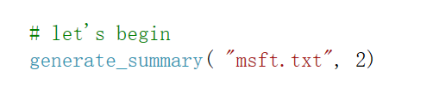
We read the msft.txt --- which is we the text we need to summary

In generate_summary function

# Step 1 - Read text anc split it

# Step 2 - Generate Similary Martix across sentences

# Step 3 - Rank sentences in similarity martix

# Step 4 - Sort the rank and pick top sentences

# Step 5 - Offcourse, output the summarize text

The result:
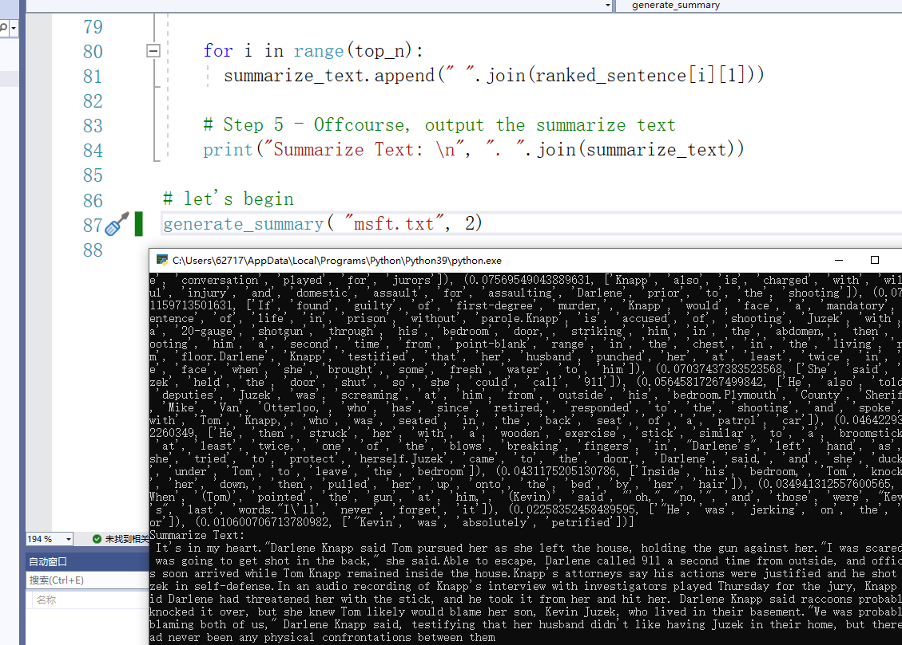
Result for msft.txt
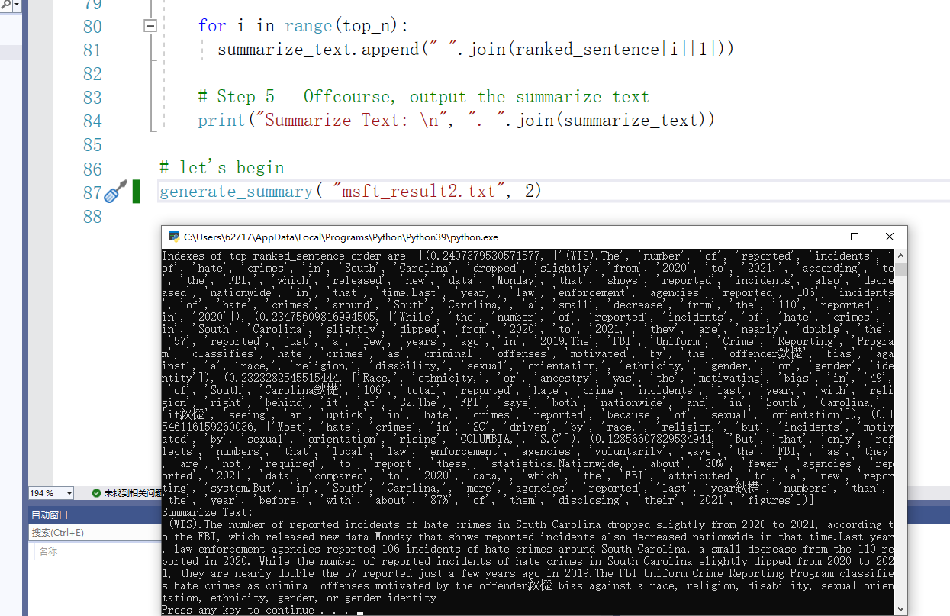
Result for msft_result2.txt

Eveluation:
in meteo.py
We chose rouge ROUGE(Recall-Oriented Understudy for Gisting Evaluation) to eveluation the result

Score=0.2×fscore​(R1)+0.4×fscore​(R2)+0.4×fscore​(RL)

Among them, R1 is ROUGE-1, which is used to measure unigram matching; R2 is ROUGE-2, which is used to measure bigram matching, and RL is ROUGE-L, which is used to record the longest common subsequence.

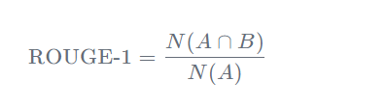

In code
We chose the human-translated text as the reference standard

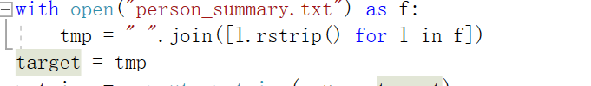
Which is person_summary.txt

Accuracy
Result 1:

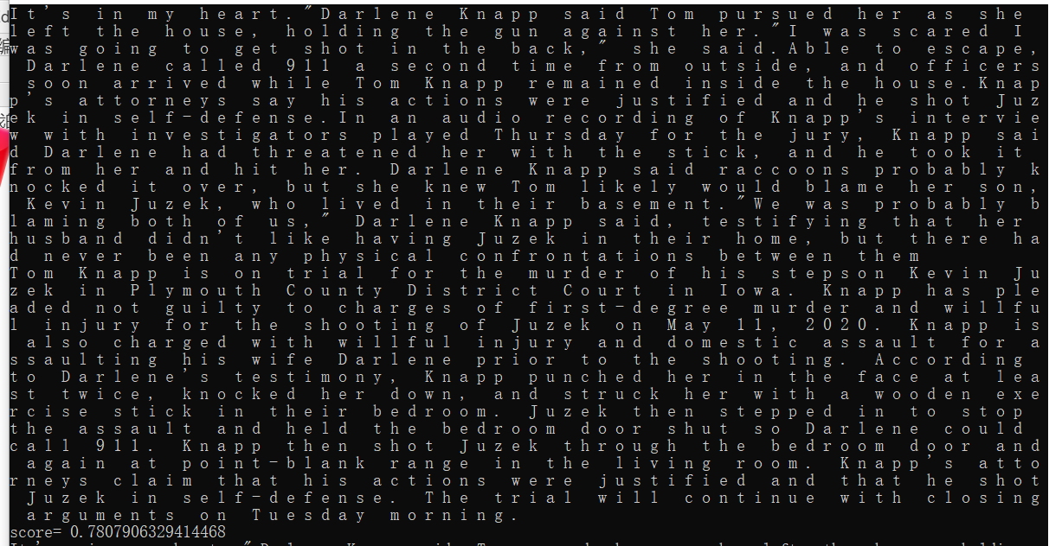

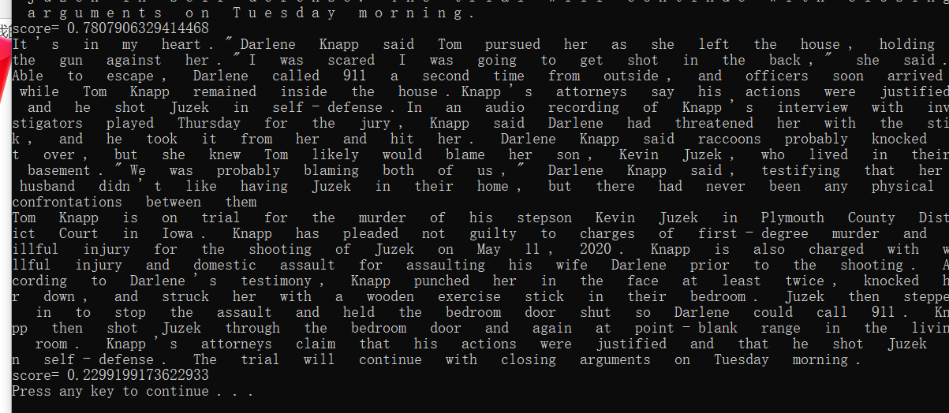

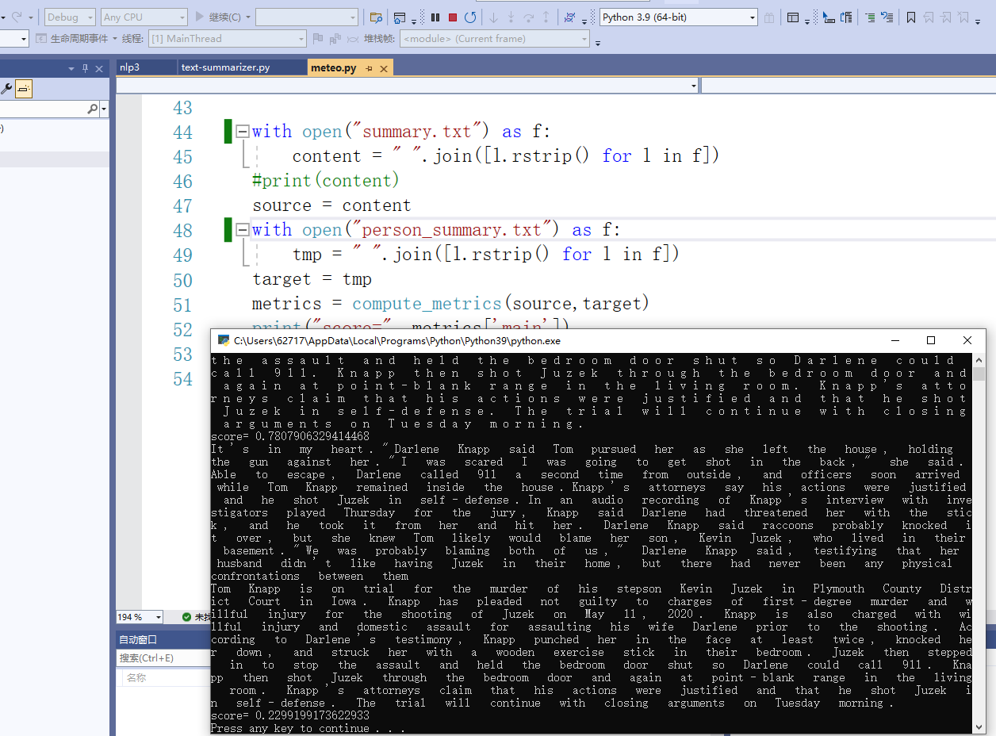

Result2:
